RocketPy
In EuRoC competition rules (EuRoC Competition Rules) section 8.5 flight simulation, it states that teams must use RocketPy to submit flight simulations with their concept and technical reports. RocketPy is a powerful Python library used for modelling high-power rocket trajectories. It uses advanced mathematical modelling and GFS weather data to produce a flight simulation. This modelling tool is exceptionally powerful in aiding our calculations and guiding our design strategy. Furthermore, with a more finalised rocket model, RocketPy can provide an integrated Monte Carlo simulation to calculate a probability distribution of the landing zone.
In order to set up a flight simulation, a multitude of parameters and setups are required. This is broken down in Figure X, where relevant important parameters are also stated for each section. Notes and helpful diagrams are also provided in Figure X the relevant stages. However, it is critical to note that Figure X is only a flowchart for a liquid rocket, as the process for a solid or hybrid rocket (both of which RocketPy supports is different).
sys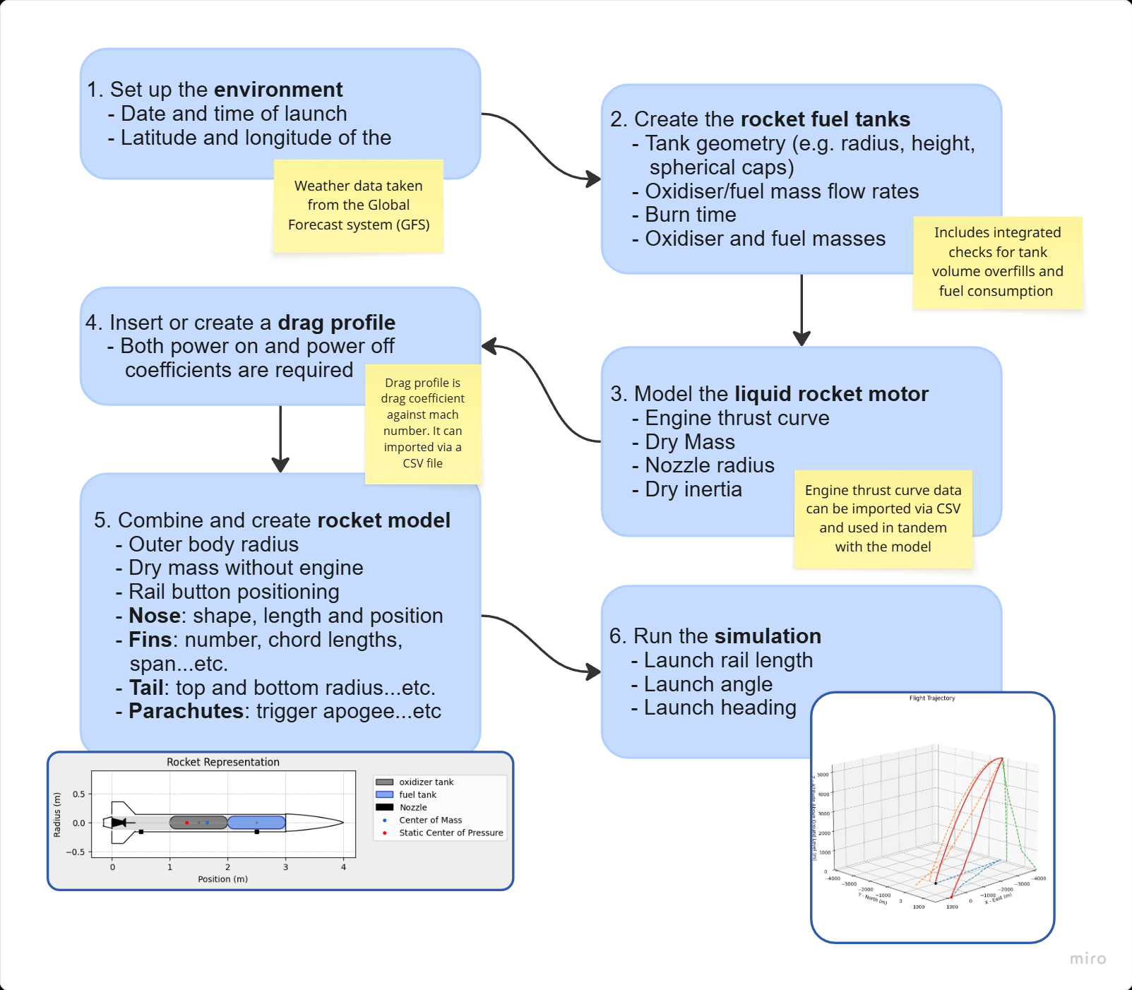

Mathematics and physics behind RocketPy
Giovani Ceotto’s team at the University of São Paulo is behind the research and development of RocketPy. The following section is a summary derived from their excellent research (Ceotto, et al., 2021). I recommend reading the paper since it contains a detailed explanation of the mathematics, physics and modelling assumptions used. In addition to the research paper, the RocketPy website has a technical documentation section where thorough records of the mathematics used are showcased (RocketPy, 2025).
Since a more in-depth breakdown of RocketPy can be found in the two sources mentioned, this summary aims to primarily highlight the architecture and mathematical modelling. Any advanced calculations are omitted, but instead the focus lies in understanding how the program processes the input parameters, converting them into an accurate rocket trajectory prediction.
RocketPy employs advanced six-degree-of-freedom flight dynamics modelling combined with detailed mass variation effects to allow for accurate trajectory predictions of custom rocket configurations. In tandem with imported weather data, the library can accurately predict rocket apogees with deviations of only the order of 1% - backed through comparisons with real-life model rockets.
While many rocket trajectory software programs have been developed and are readily available, RocketPy distinguishes itself by its incredible efficiency, high accuracy and integrated Monte Carlo dispersion analysis. The latter is actually the primary intent behind the library. Because of the high number of calculations required to run a Monte Carlo analysis, the code has been highly optimised to run a full simulation in a second or less, a testament to the incredible efficiency achieved. Table 1 showcases a comparison of previous rocket trajectory simulators along with the new features RocketPy brings.
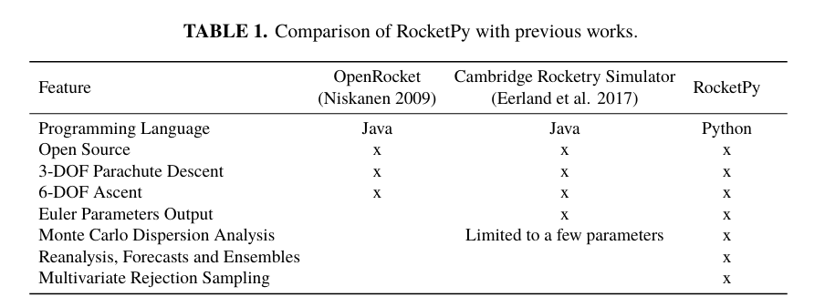

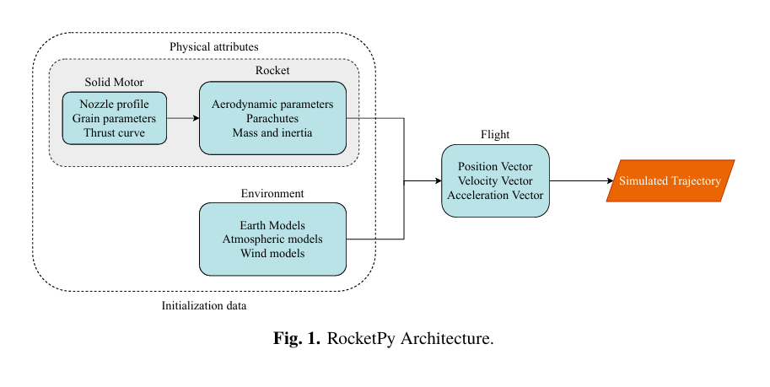
A generalised data flow chart can be found in Figure X. The user is expected to input various data about the rocket, categorised into three sections: Motor, Rocket and Environment. The motor data is fed into the rocket to produce an accurate overall model, which, when combined with the environment data, will allow the program to calculate and predict a flight trajectory.

Environment
From an input launch time, longitude, latitude and elevation, RocketPy can automatically pull real weather data from various meteorological agencies across the world. When selecting the specific data source, it is important to distinguish between forecasts and reanalysis. Reanalysis uses atmospheric conditions based on averages from adjacent days in the same season from previous years. On the other hand, forecasts use a numerical prediction method which takes into account different kinds of uncertainties, taking into consideration model inadequacies and the nature of the phenomena.
The key outputs from the environmental atmospheric model are:
- Wind speed
- Wind direction (where the wind blows)
- Wind heading (towards which the wind blows)
- Speed of sound
- Air density
- Dynamic viscosity
All of these parameters are provided as a function of altitude.
Another key note is that RocketPy uses a simple flat earth model (OpenRocket can use different models, such as WGS84 Ellipsoid), resulting in a less accurate model, as gravitational acceleration is fixed. In reality, the gravitational constant varies with altitude. The model was chosen because the lower apogee flights did not benefit from a more complex model, which would come with a greater processing time.

Motor Model
Initially, RocketPy was only developed with a solid rocket motor; thus, the research paper only discusses the solid motor parameters and the respective analysis. Despite this, the analysis with a liquid motor does carry many similarities and is processed by RocketPy in much the same way. It is important to mention that the motor in a rocket refers to both the propellant tanks and the engine.
Our rocket uses liquid propellant and a separate oxidiser and fuel tank.
Key Parameters:
- Tank geometry (including position)
- Mass flow rate (both oxidiser and fuel)
- Thrust profile (Can be a model or directly imported via a CSV file)
- Dry inertia
- Dry mass
These parameters allow for the calculation of the changing CM and the relative distance r_{m} from the CDM (centre of dry mass) – important later when calculating the aerodynamic effects. Furthermore, the thrust profile gives the thrust force as a function of time.

Rocket Model
Other trajectory software, such as OpenRocket, can automatically calculate the rocket’s inertia tensors based on the rocket's geometry and materials, but RocketPy simply asks for an overall tensor. Similarly, aerodynamic coefficients could also be calculated via wind tunnel data or computational fluid analysis, but RocketPy does not support this. Both inertia tensors and drag coefficients (as a function of Mach speed) are to be manually imported.
However, RocketPy does calculate the individual lift coefficients and centre of pressure of the common lifting surfaces (nose cones, fins and tails) using Barrowman’s method. Adding in the parachute data and launch rail parameters, the equations of motion are ready to be solved for the rocket.
Key Parameters:
- Nose cone geometry
- Fin geometry
- Parachute variables
- Launch rail settings and conditions

Flight Overview
The flight is split into 3 sections:
- Launch rail phase – rocket is sliding on the guide rail
- 6-DOF flight – free motion through the air during powered and coasting flight
- Descent under parachute – slowed descent with 3-DOF modelling

RocketPy uses two coordinate systems for its equations of motion – see Figure 2.
- frame – Body frame, fixed to rocket
- frame – Earth frame, fixed to Earth

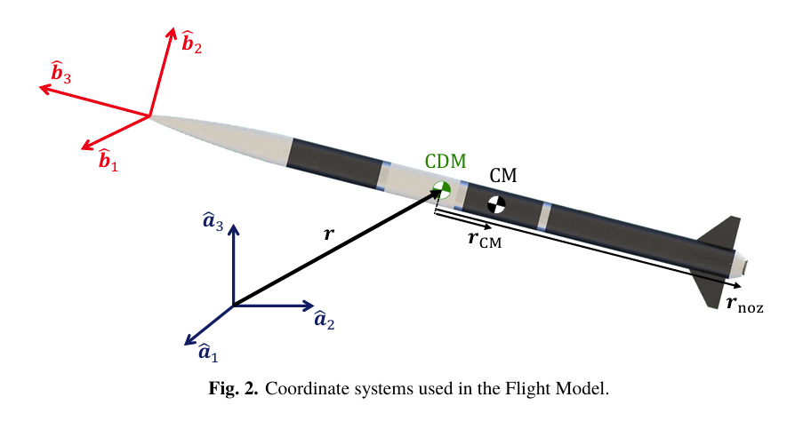

To calculate the trajectory, the state vector u is constantly tracked and updated. The state vector (u) contains:
$$u=[r,v,q,ω]$$
- r: position of the rocket’s center of dry mass (relative to its initial position, i.e. coordinates)
- v: velocity (time derivative of r)
- q: quaternion representing rocket attitude (avoids Euler angle singularities)
- ω: angular velocity in the body frame

A quaternion is a tool used to describe rotations in a 3D space. It is represented as
$$q=w+xi+yj+zk$$
Where
- $w$: scalar part
- $x,y,z$: vector part
- $i,j,k$: imaginary units with special multiplication rules
To help understanding, the scalar part represents the magnitude of the rotation, whilst the imaginary vector part helps determine the direction of the rotation.
They are preferred over Euler Angles because they avoid Gimbal lock – where two rotational axes align, causing a loss of a degree of freedom.
Imagine Euler angles as defining rotation via individual rotations about 3 axes, whilst quaternions allow for one fluid rotation in a set direction.
The time derivative of this can be found from the angular velocity using the following equation:
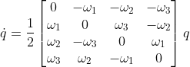

Phase 1 - Launch rail phase
Modelled as a 3D rigid body with various forces and moments of inertia applied at different points, but since the rocket is contained within the rail, the motion is restricted to only 1D
Has only translational motion since the Rocket is constrained in the launch rail.
Forces considered:
- Thrust – a function of time
- Weight – changing with burning propellants
- Aerodynamic drag – calculated based on relative wind speed data from the environment and provided drag coefficient at the state Mach number
- Rail reaction forces – forces along the axis of the rail/rocket are neglected
Key points:
- No rotation
- The EOM accounts for the changing CM of the rocket as propellant is burnt
- Rocket’s orientation is fixed until it leaves the rail

Phase 2 – 6-DOF Flight
Modelled as a 3D rigid body with various forces and moments of inertia applied at different points
Has both translational and rotational motion (hence 6-DOF)
Forces considered:
- Thrust – still a function of time
- Weight – changing (function of time)
- Aerodynamic forces – both lift (normal) and drag (axial)
Key Points:
- Each aerodynamic surface (fin, nose cone, etc) has its own centre of pressure (the point at which all aerodynamic forces can be modelled to act from)
- The relative wind velocity taken from the environment data is considered at each surface
- Using this, the angle of attack and then the lift force (normal to the rocket) can be calculated
Translational motion:
$$m\dot{v}=\text{forces from thrust, drag, lift, gravity, and mass variation}$$
Includes terms for:
- Movement of the centre of mass as fuel burns.
Rotational motion:
$$I\dot{ω}=\text{moments from lift forces, jet damping, gravity, etc.}$$
$I$is the time-varying inertia tensor.
- Includes gyroscopic and jet damping effects (stabilising effects from exhaust flow).
Assumptions:
- No fuel slosh (changing CM for fuel)
- Steady state motor (changing transient effects are negligible)
- Exhaust gases have a uniform velocity profile at the nozzle’s exit, without swirl

Phase 3 – Parachute slowed descent
3D single point mass with only translational motion
Forces considered:
- Parachute Drag – wind relative speed and drag coefficients are used here
- Weight
Key Points:
- No rotation is considered
- Provides an estimation of descent rate and landing velocity
- Horizontal velocity from the wind data is considered here to help determine the landing spot.
Key Assumptions:
- Point mass
- Instantaneous parachute deployment

Numerical Integration
To solve the differential equations set up by the forces and moments, it uses an advanced numerical integration scheme called LSODA. LSODA can automatically switch between different numerical methods depending on the stiffness of the equations (how rapid the response varies).
- For non-stiff, stable rocket flight, it employs a variable order, up to 13th order, variable time step Adams-Moulton predictor-corrector scheme.
- For stiff, unstable flight, it uses Backward Differentiation Formula methods
- It automatically changes the step size dynamically in response to the stability of the equation to maintain accuracy whilst minimising computation time.

Step-by-step explanation of each cycle:
Reminder of the state tensor
$$u=[r,v,q,ω]$$

- Read current state $u(t)$
- Compute current forces, moments, derived quantities (mass, inertia, drag, lift…)
- Evaluate $\dot{u}(t)=f(u,t)$ – The main bulk of the mathematics, for each quality (position, velocity, attitude and angular velocity), the derivative function is evaluated. For velocity and angular velocity, their time derivatives are determined by solving the differential equations set up. Attitude, q, is determined from the relationship between quaternions and angular velocity mentioned earlier.
- LSODA integrates $u(t)→u(t+Δt)$with adaptive Δt
- Update $r,v,q,ω$
- Check for events (rail exit, apogee, parachute, impact)
- Switch phase if needed, then repeat

A flow chart of the integrator architecture is found below:
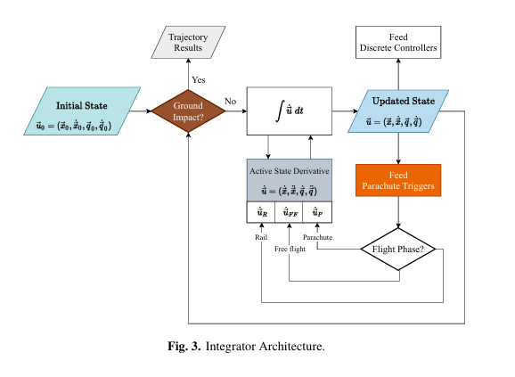

References
Ceotto, G. H. et al., 2021. RocketPy: Six Degree-of-Freedom Rocket Trajectory Simulator. Journal of Aerospace Engineering, 34(6).

